Salesforce Day-2
Gunta Sai Koushik
Regd No: 23PA1A4544

Task 1 – Apex Collections (List, Set and Map)
Introduction
Collections are data structures used to store multiple values in Apex. Salesforce provides three main collection types:
- List
- Set
- Map
List
Definition
A List is an ordered collection of elements. It allows duplicate values and preserves the order in which elements are inserted.
List<String> cities = new List<String>();
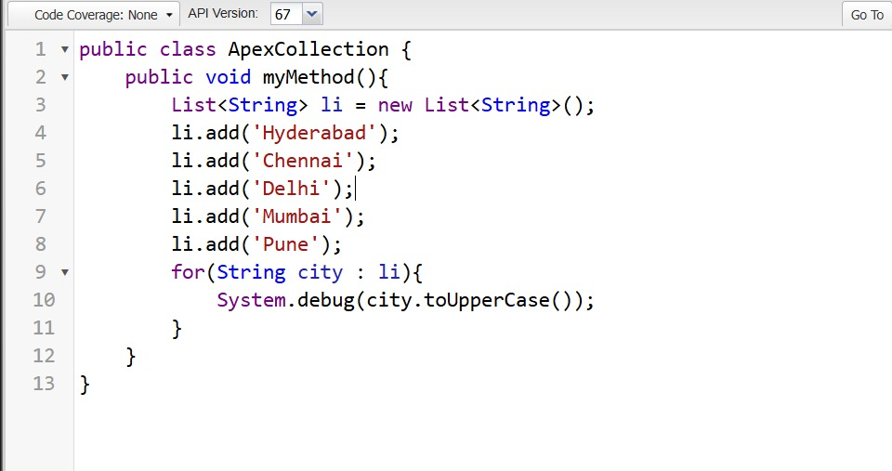
List code — building a List<String> of city names and printing each in uppercase
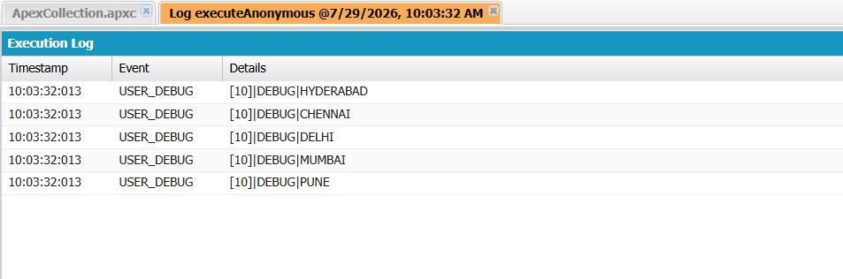
Execution log — List output showing all 5 cities in uppercase
Set
Definition
A Set stores only unique values.
Set<String> cities = new Set<String>();
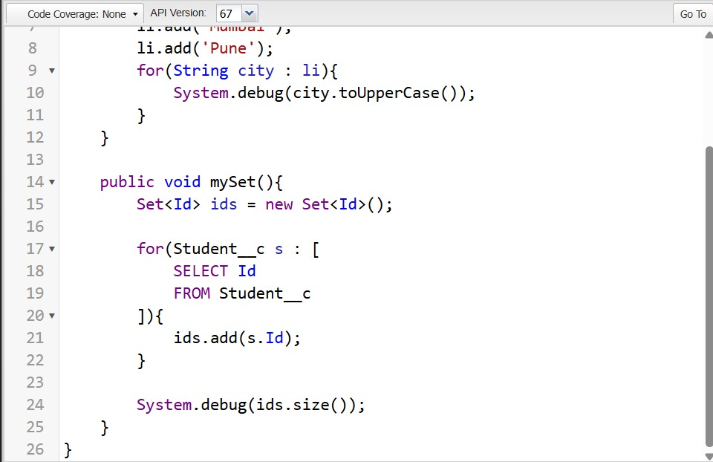
Set code — building a Set<Id> from a SOQL query on Student__c
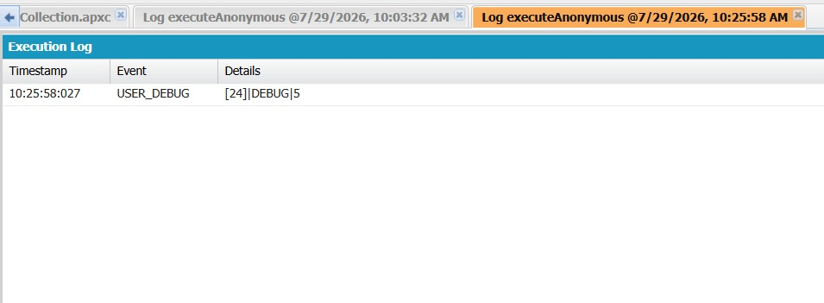
Execution log — Set output showing the distinct record count
Map
Definition
A Map stores data as Key-Value pairs.
Map<Id, Student__c> studentMap =
new Map<Id, Student__c>();
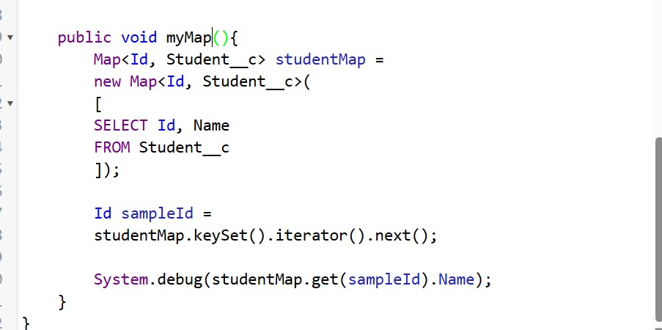
Map code — building a Map<Id, Student__c> and looking up a record by Id
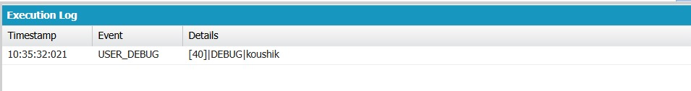
Execution log — Map output showing the field value ('koushik') for the looked-up Id

Task 2 – Governor Limits & Bulkification
Governor Limits
Salesforce is a multi-tenant platform where many organizations share the same resources. To ensure fair usage, Salesforce enforces Governor Limits.
Examples:
- Maximum SOQL Queries = 100
- Maximum DML Statements = 150
- Heap Size Limit
Break It — Bad Trigger (SOQL inside a for loop)
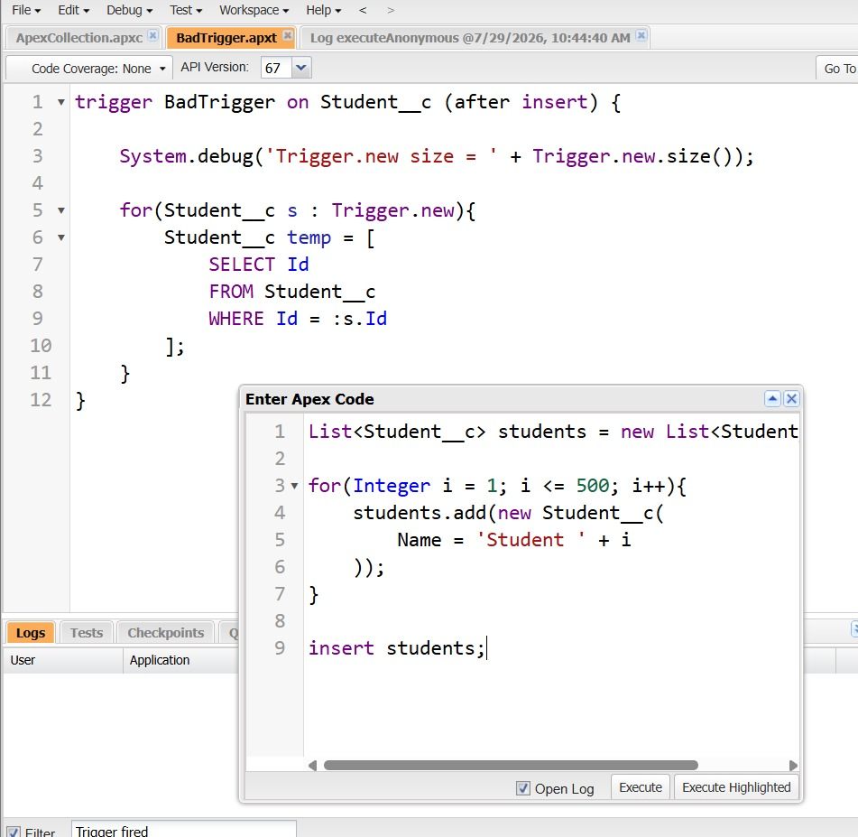
BadTrigger.apxt — SOQL query placed inside the for loop, with the bulk insert script (500 records) used to trigger the failure
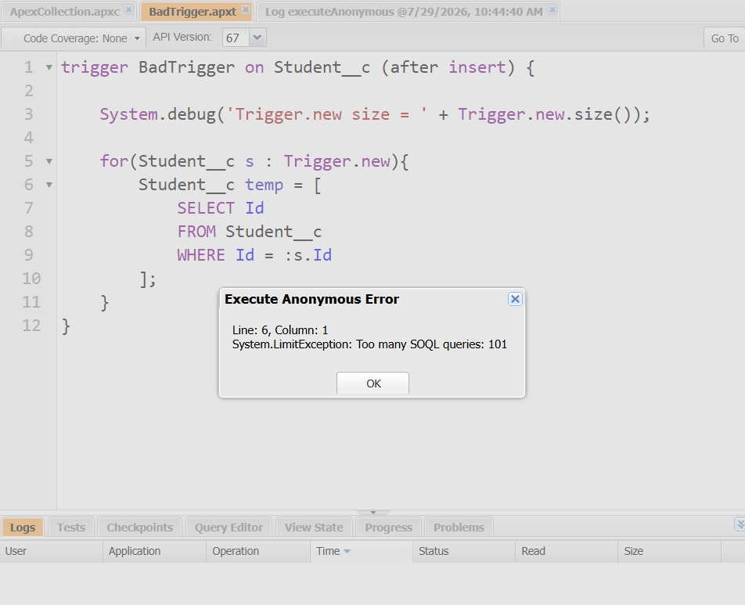
Execution Anonymous Error — 'Too many SOQL queries: 101', confirming the governor limit was hit as expected

Task 3 – Asynchronous Apex
What is Asynchronous Apex?
Asynchronous Apex executes code in the background without making users wait.
Future Apex
Future methods execute after the current transaction completes.
Rules
- Must be static
- Returns void
- Uses @future annotation
- Accepts only primitive parameters
Future vs Queueable vs Batch Apex
Feature | Future | Queueable | Batch
Execution | Background | Background | Background
Parameters | Primitive Only | Complex Objects Allowed | QueryLocator/Iterable
Chaining | No | Yes | Yes
Job Monitoring | Limited | Better | Full
Best For | Small Tasks | Medium Complexity | Millions of Records

When to Use
Future Apex — Used for:
- Updating records
- Sending emails
- HTTP Callouts
Queueable Apex — Used for:
- Complex processing
- Passing collections
- Chaining multiple jobs
Batch Apex — Used for:
- Large datasets
- Nightly jobs
- Millions of records
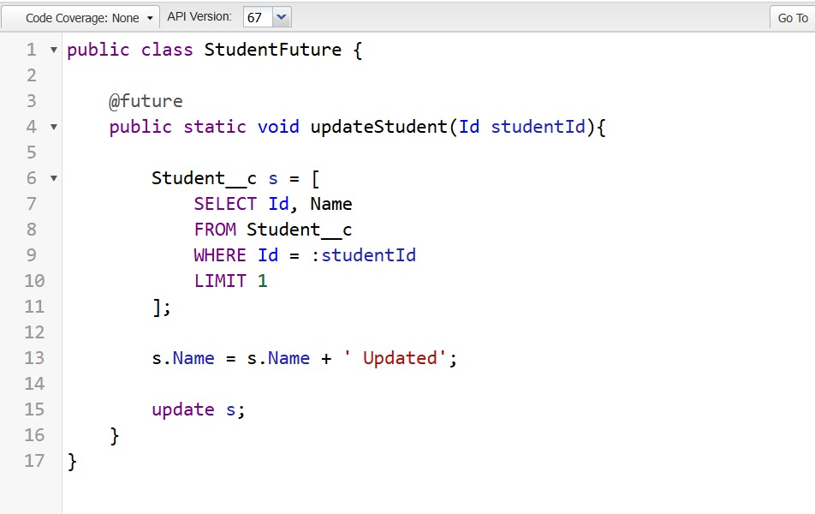
StudentFuture.cls — @future method that updates a Student__c record
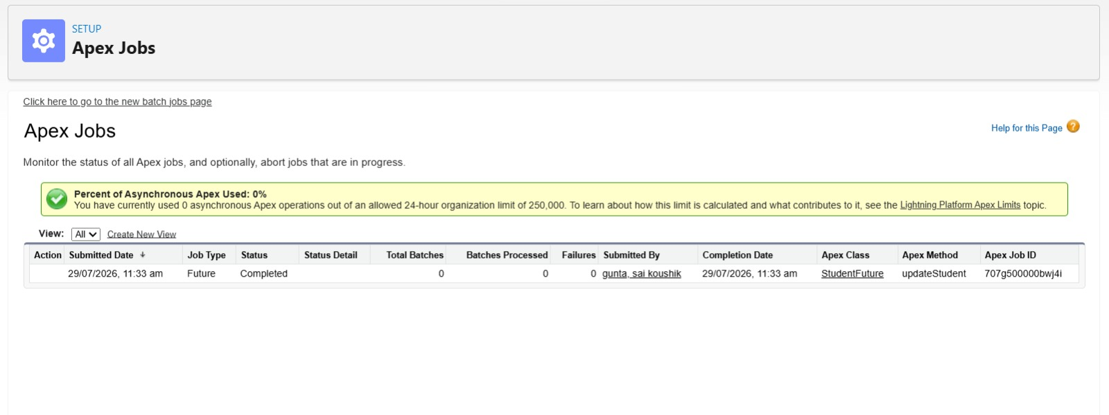
Setup → Apex Jobs — confirming the future job 'updateStudent' completed asynchronously

Task 4 – Lightning Web Components (LWC) Component Communication
Objective
The objective of this task was to understand how Lightning Web Components communicate with each other using Parent-to-Child and Child-to-Parent communication.
Parent-to-Child Communication
Parent-to-Child communication is achieved using the @api decorator. The parent component passes data (such as a recordId) to the child component through a public property. The child receives the value and displays the required record information using Lightning Data Service (getRecord).
Child-to-Parent Communication
Child-to-Parent communication is implemented using Custom Events. When the user clicks a button in the child component, it dispatches a custom event. The parent component listens for this event and updates its user interface accordingly.
Key Concepts
- @api is used to expose public properties or methods to parent components.
- Custom Events allow child components to notify parent components of user actions.
- Lightning Data Service (LDS) is used to retrieve Salesforce records without writing Apex code.
Outcome
Successfully implemented communication between two Lightning Web Components where:
- The parent passed a Student record Id to the child.
- The child displayed the Student details.
- The child sent an event to the parent.
- The parent received the event and updated the displayed message.
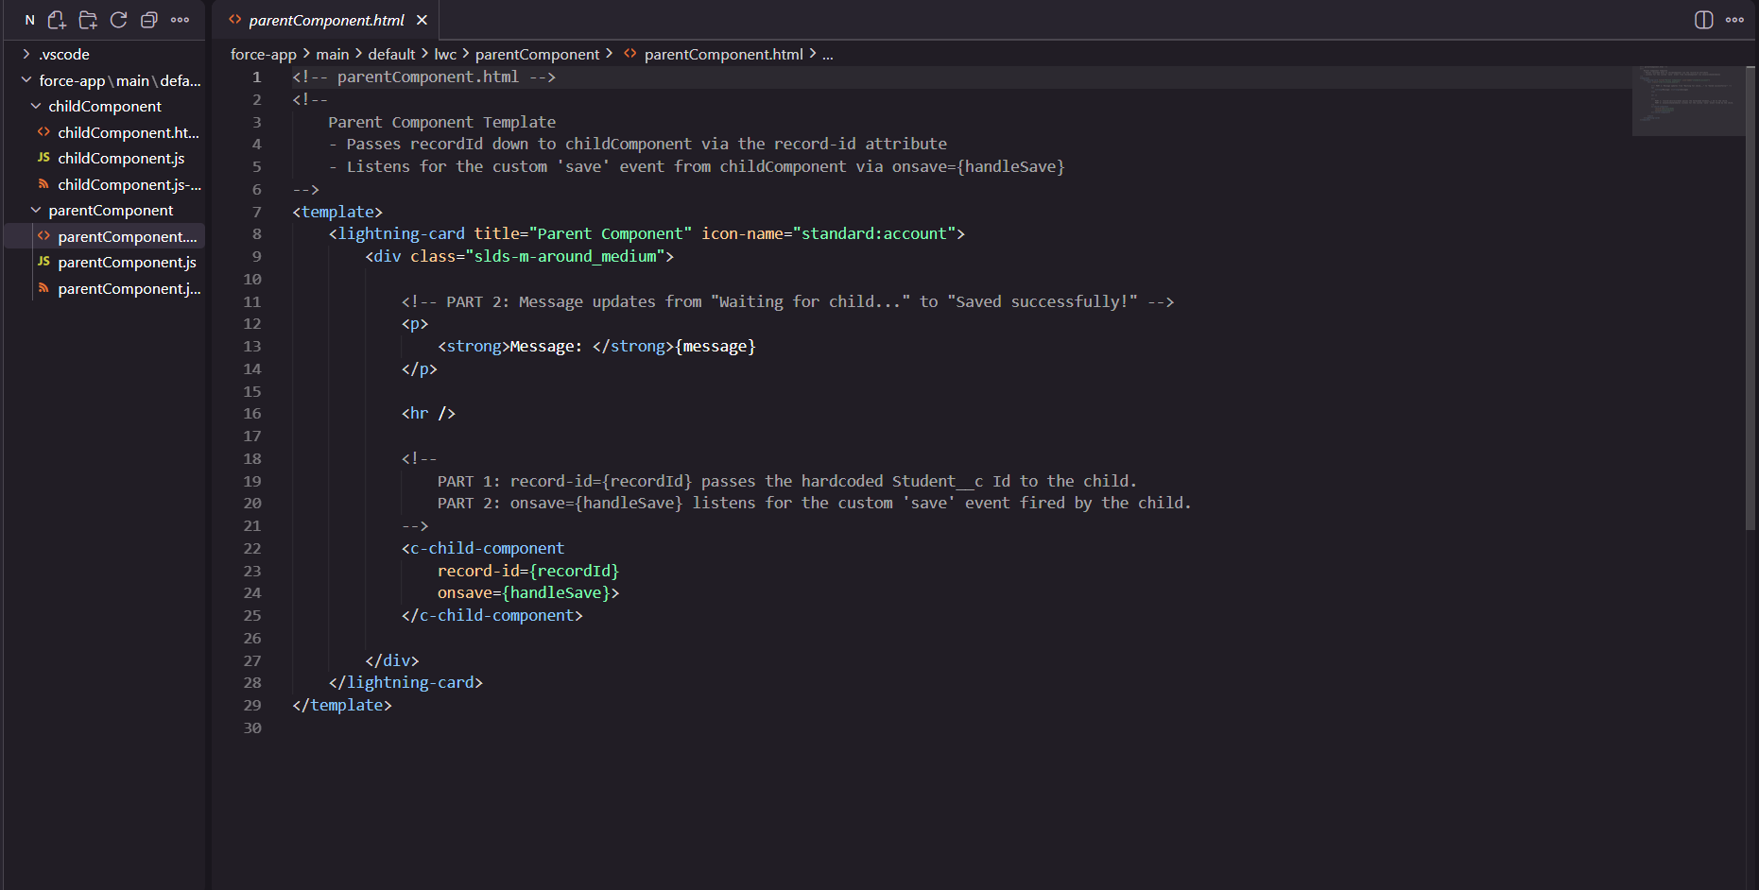
parentComponent.html — passing recordId to the child and listening for the 'save' event
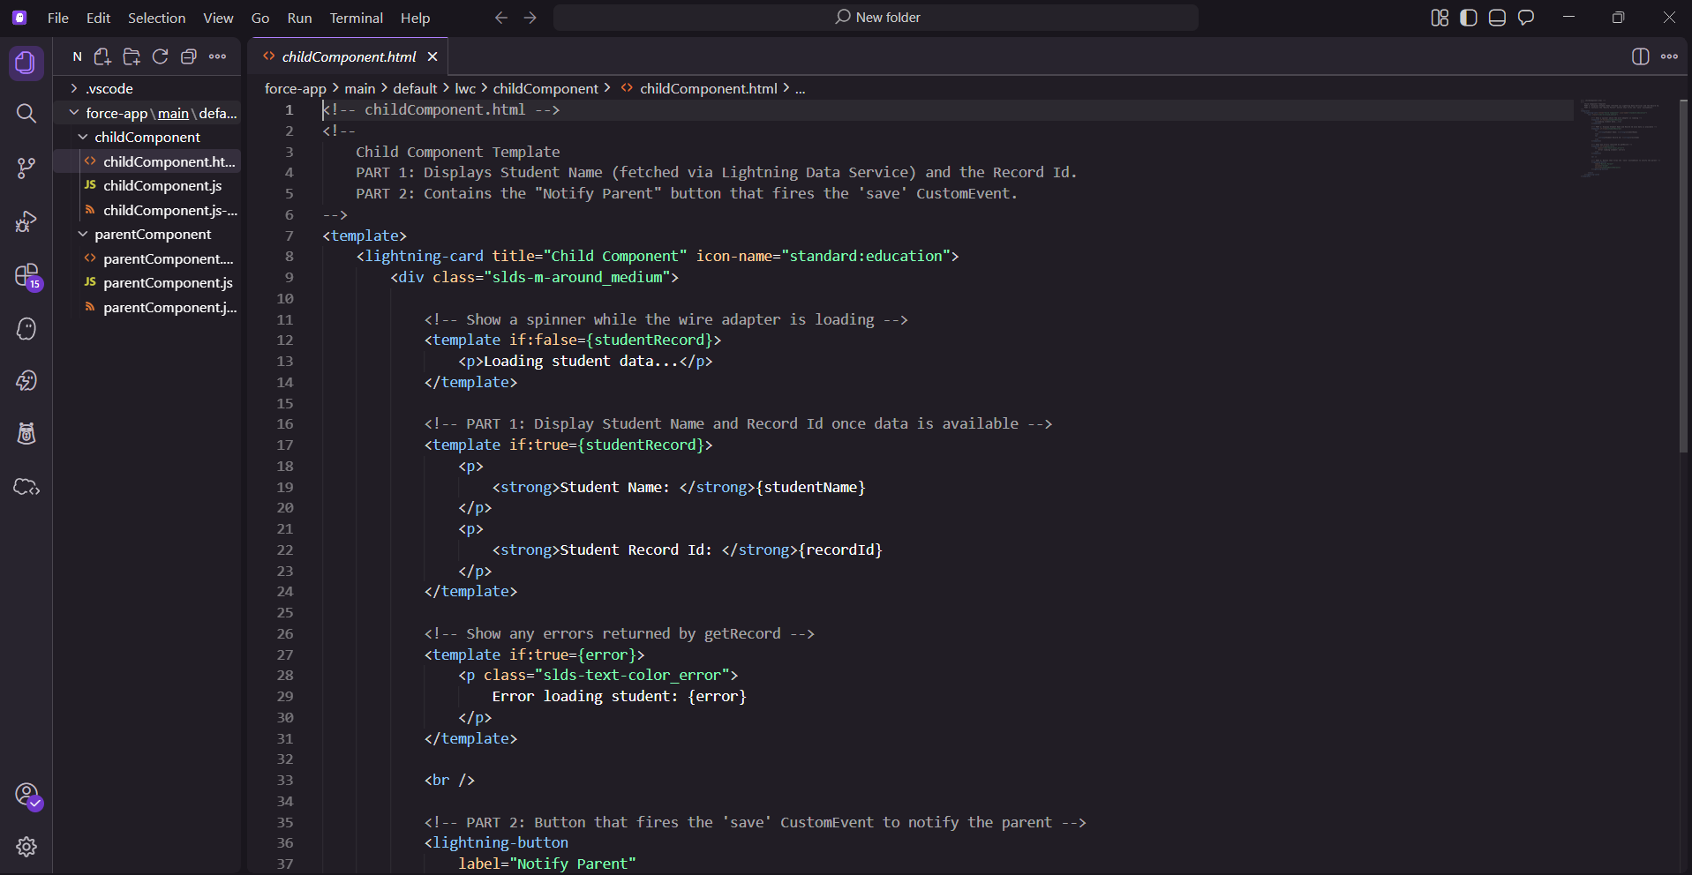
childComponent.html — displaying student data via Lightning Data Service and firing the 'Notify Parent' custom event
Demo Video (Google Drive): View Recording

